# MINI PROJECT (2019-20)

**Alumni Connect**

**MID-TERM REPORT**

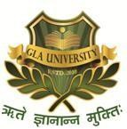

**Institute of Engineering & Technology**

**Submitted by**

**Ashita Vijay Seth**

**(181500145)**

**Prakhar Singh**

**(181500470)**

***Supervised by:***

**Mr. Neeraj Khanna**

# Department of Computer Engineering & Applications

**Content**

|  |  |
| --- | --- |
| **Abstract** | **3** |
| **1. Introduction** | **3** |
| 1.1 The Problem Statement | **3** |
| 1.2 Area of Computer Science | **4** |
| 1.3 Hardware and Software Requirements  1.3.1 Hardware Requirements  1.3.2 Software Requirements | **6**  **6**  **6** |
| **2. Objectives** | **6** |
| 3**. Implementation Details** | **7** |
| **4. Progress till Date & The Remaining work** | **7** |
| **5. Some Screenshots** | **8** |
| **6. References** | **23** |

**Abstract**

Alumni are resources that can provide meaningful and mutually beneficial relationships over time.

We came up with an idea of connecting the students with their alumni though an application-“Alumni connect”. It will make the Education Platform better by bridging the gap between student and Alumni.

Moreover, it will help the students in many different **ways, like** - facing interviews, Internship opportunities, training opportunities, myths about corporate life, and many more. The students get to know their alumni’s Experiences and avoid doing the mistakes their alumni did. They can get a closer look at the corporate world. The Alumni would act as a Mirror to the corporate world. This application will welcome many opportunities which will be beneficial for the students and their career..

# Introduction

* 1. **The Problem Statement**

An alumnus is a term used for former person specifically a student, of a particular school, college or University.

During one of a Meet-up with our Alumni, we started talking about the life in corporate. He told us about the how he started off as a beginner and is now doing great in his field. He told us the things that he wished he could knew earlier. We realized that there are a lot of myths going around about the corporate life. Myths like – “We don’t have to work hard after securing a good job” or “Everything is taught to us during the 4 years of college”. Corporate Life is not about studies, it is so much more.

Apart from this, we ended up discussing about how IIT-ians (Students of IIT) do great in every sector and secure a very good job. He told us that in IIT’s students keep in touch with the alumni, which not only help them to learn about corporate sector but also helps them to score a good internship or training program in a valuable organization.

Alumni serve many valuable roles, such as:

1. Helping to build and grow an institution’s brand through word-of-mouth marketing. For instance, positive posts on social media can create buzz and increase application rates.
2. Can provide mentoring, internships, and career opportunities to students.
3. Any career related opportunities that benefit the students. Alumni are resources that can provide meaningful and mutually beneficial relationships over time

Through this meet-up we realized the importance of Alumni, so we decided to develop an app where the students can connect with their alumni.

# Area of Computer Science

## The Alumni Connect application is an android application which mainly aims to improve communication between Alumni and students. This application actually consists of two modules, those are the Admin module (Admin) and Student module(User), where they can access and operate the application from their respective ends. We focused on both sides which will help both the Alumni and the students.

## In general, the Admin will maintain the entire administration like Authorization, Authentication, permissions, History tracking, and troubleshooting, etc. The Admin (Alumni) can share the job opportunities or any important notices which they would want to share with the students. Also, the Admin can share e-books, Question-Answer PDF, Interview Questions, etc. to the students through our Admin panel. Admin Panel also includes basic activities like adding new Alumni, updating an existing Alumni and deleting an existing Alumni. Alumni can also share their experience, be it interview experience, work experience or any other real life experience which may benefit the students in one way or the other.

## The application is made extremely user friendly.

## The Student will access all information like notices, PDFs, e-books, etc. and maintain a good relationship with the alumni. They can send or receive any kind of information like Clarification, Queries and guidance by connecting with the alumni. The student can ask for Doubts in Alumni section. Students can get the latest information regarding career opportunities and career guidance. Whenever in doubt, they can consult to their alumni regarding that issue. Also, they get to know their Experience and avoid doing the mistakes their alumni did. They can get a closer look at the corporate world. The Alumni would act as a Mirror to the corporate world.

## In this Alumni Connect Android project, we are proposing a new form of technology to get communication between Alumni and Students.

## Give Below is the workflow diagram of the project-

Admin Application

(Alumni App)

View Alumni

Delete Notice/Article

Upload Images

Upload Study Material

Upload Notice/Article

Update info

Add Alumni

Delete Alumni

# Dig 1.2.1. Work flow diagram of Admin Application

User Application

(Student application)

Study Material

Websites

About College Life

Alumni Details

Notices/

Articles

Home

Gallery

Download Study material

Connect to Alumni

# Dig 1.2.2. Work flow Diagram of User Application

# Hardware and Software Requirements

# 1.3.1 Hardware Requirements

* + 1. System: Intel i3 3rd generation or above
    2. Hard Disk: 40GB
    3. 1 GB RAM Required(Min.)

**Limitations and Constraints**:

* The Phone must be connected with Internet
* This app can only be installed on android devices

# 1.3.2 Software requirements

* + - Any OS
    - Coding Languages: Java
    - Back End: Firebase
    - Tool Kit: Android SDK
    - IDE: Android Studio
    - Adobe Illustrator

# Objective

## The main objective of this project is to improve communication between Alumni and Students. With this project, we aim to create a meaningful relationship with our alumni.

## As told earlier, alumni are resources that can provide meaningful and mutually beneficial relationships over time. We aim to provide students with opportunities through our alumni in every sector. A valuable guidance, a mirror to the corporate world, we want the students to know it all before they enter the corporate world. We want the students to know, what our alumni would have wanted to know when they were that young.

## During the last Semester, we have worked on the project “E-bridge GLAU”, that acted as a bridge between students and the faculty. We aim to continue our project and turn it to a bridge between Alumni and Students.

# Implementation Details

**Part1:**  Connecting the application to firebase and creating database.

**Part2**: Connecting all the modules of the application to firebase database.

**Part3:** Testing Uploading and Downloading of documents and images.

**Part4:** Setting up sign up and login authentication.

**Part5:** Adding push notification feature

**Part 6**: User data verification by admin App

1. **Progress till Date & The Remaining work**

Part 1 is completed (Need Some Changes): We have successfully connected the application with firebase

Part 2 is completed: We have also connected each module with firebase database

Part 3 is completed: We have tested the uploading and downloading of data, data uploaded from Admin app is successfully loading on User app. Also, we can download the documents successfully.

Part 4 is ongoing: We are working on signup page.

Overall, our 60% of work has been completed.

# Screenshots

# As we are editing in the previous E-Bridge Application, we are yet to change the respective names for the app. Hereby, anything related to faculty should be interpreted as alumni and anything related to PDF’s or e-books should be interpreted as study material.

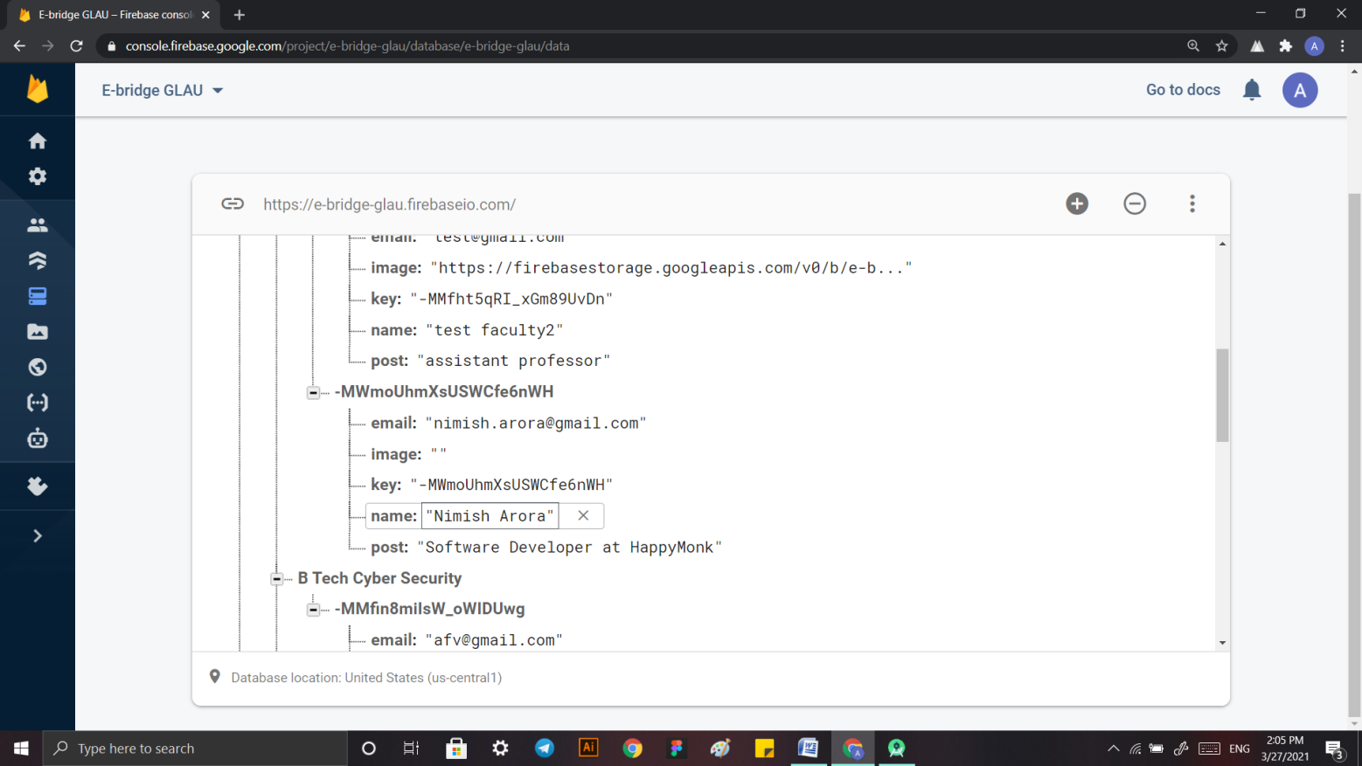

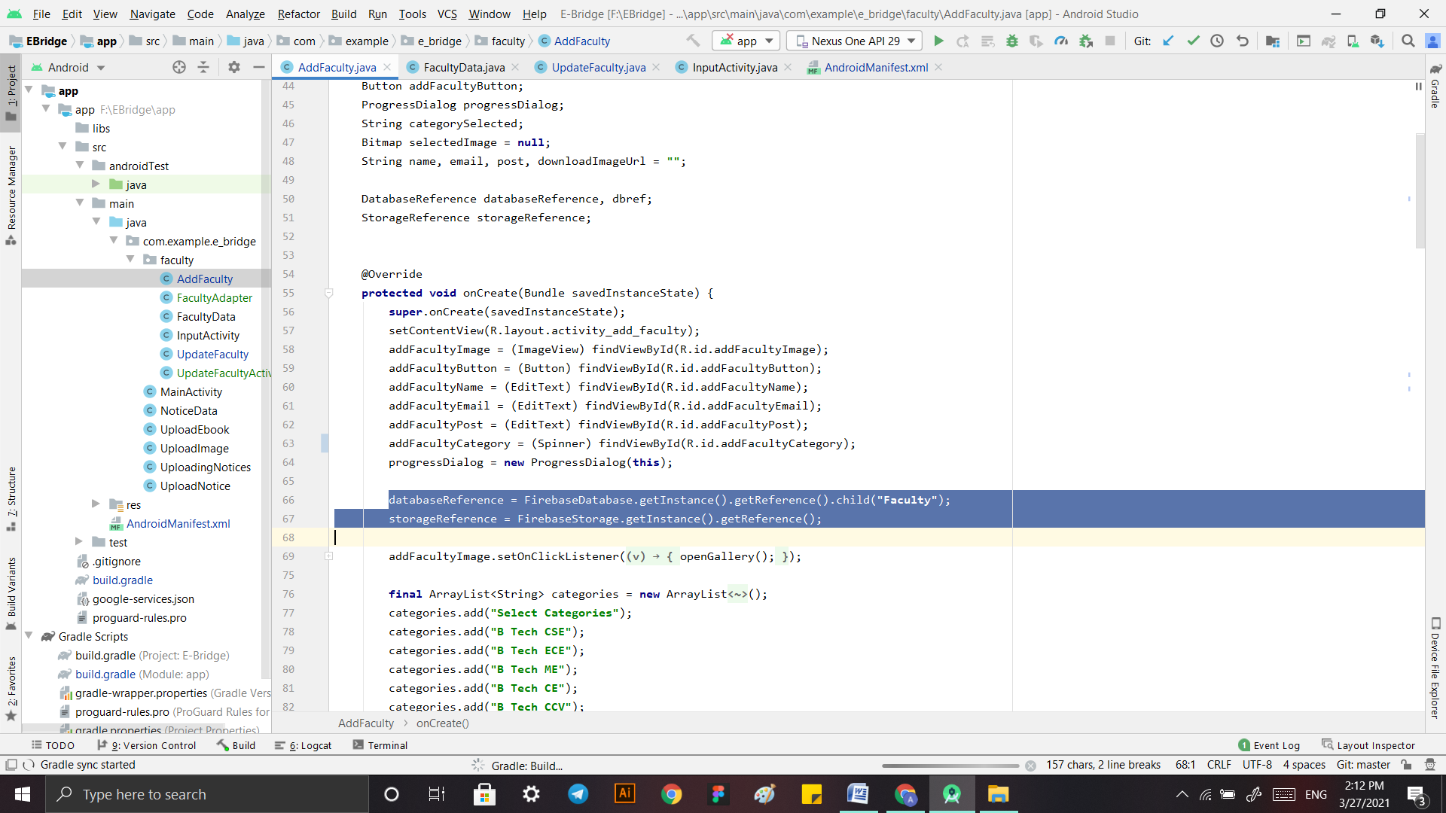

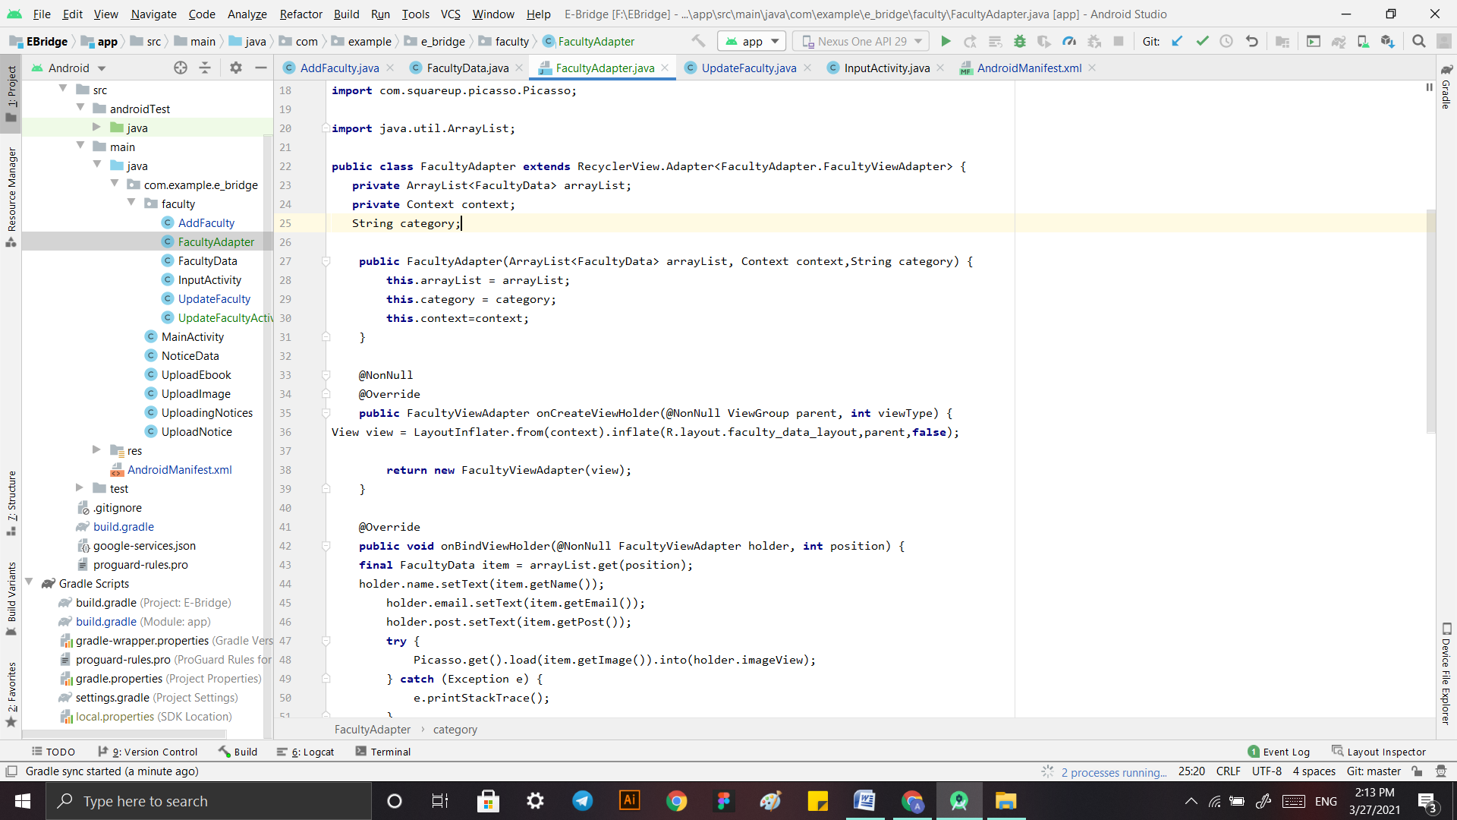

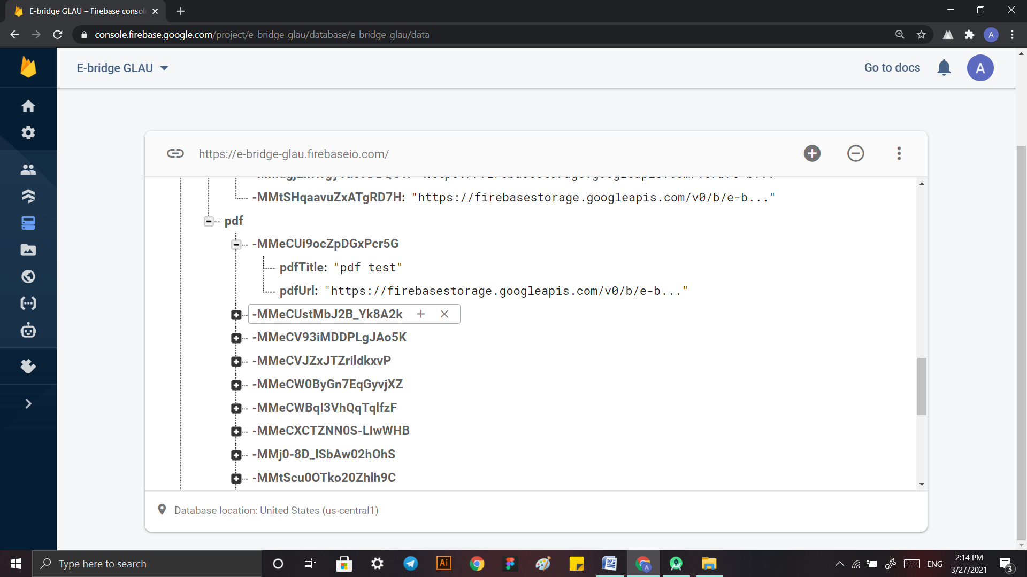

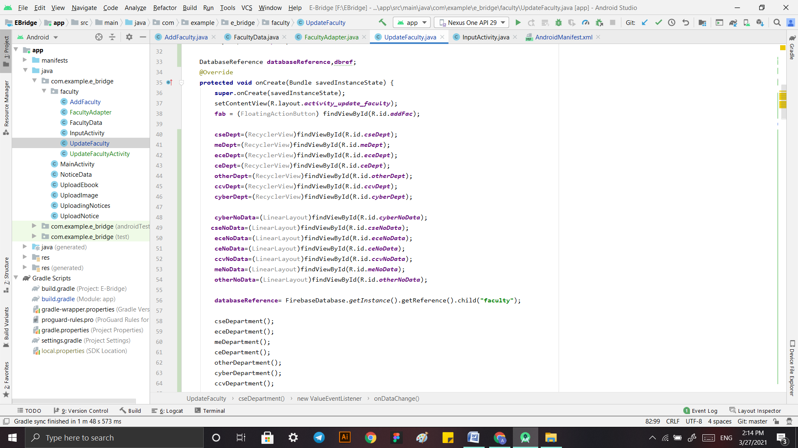

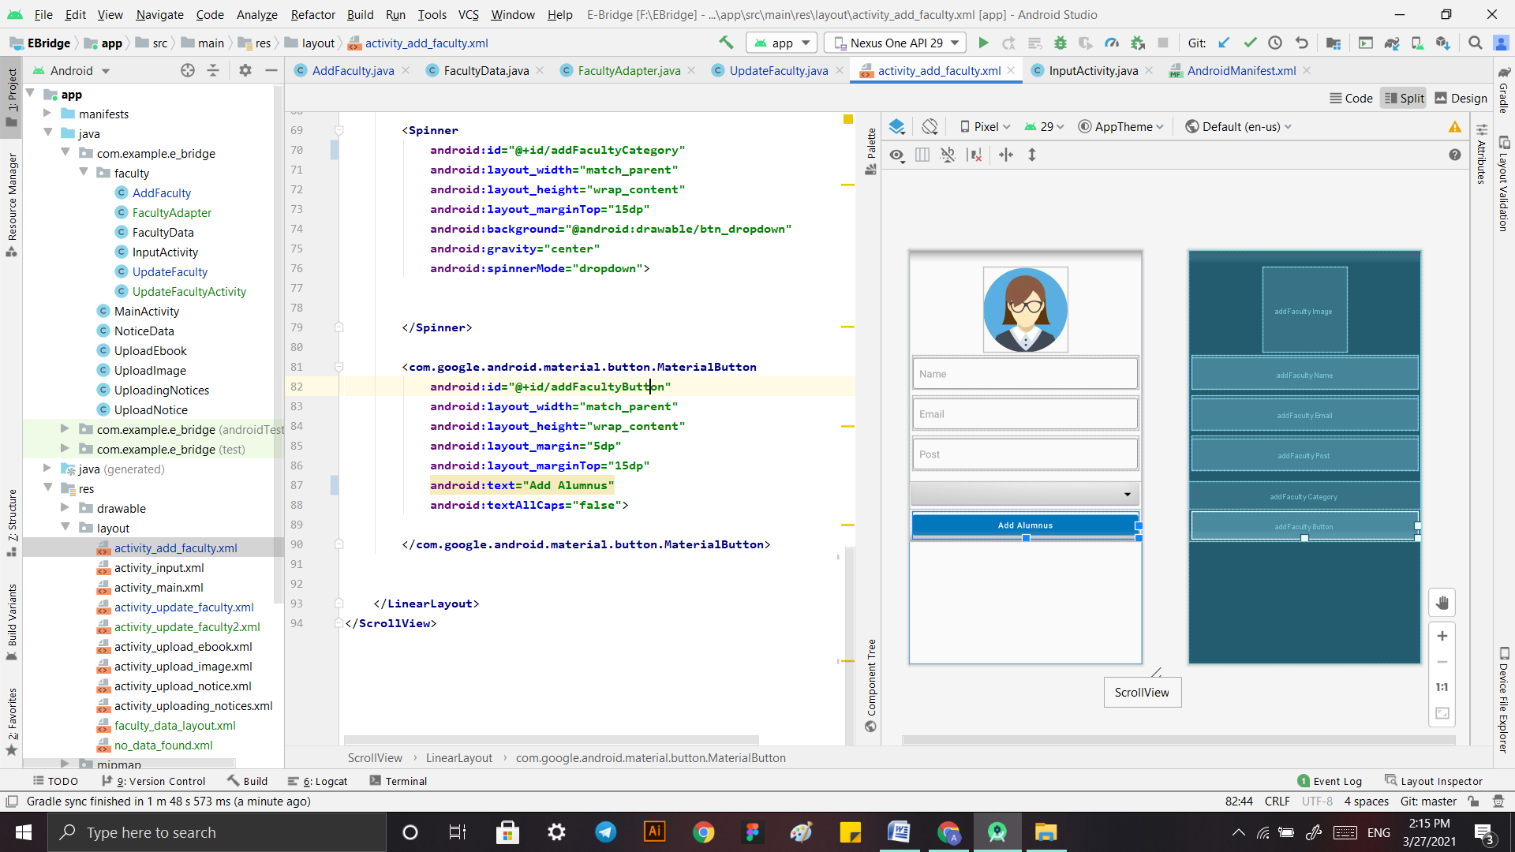

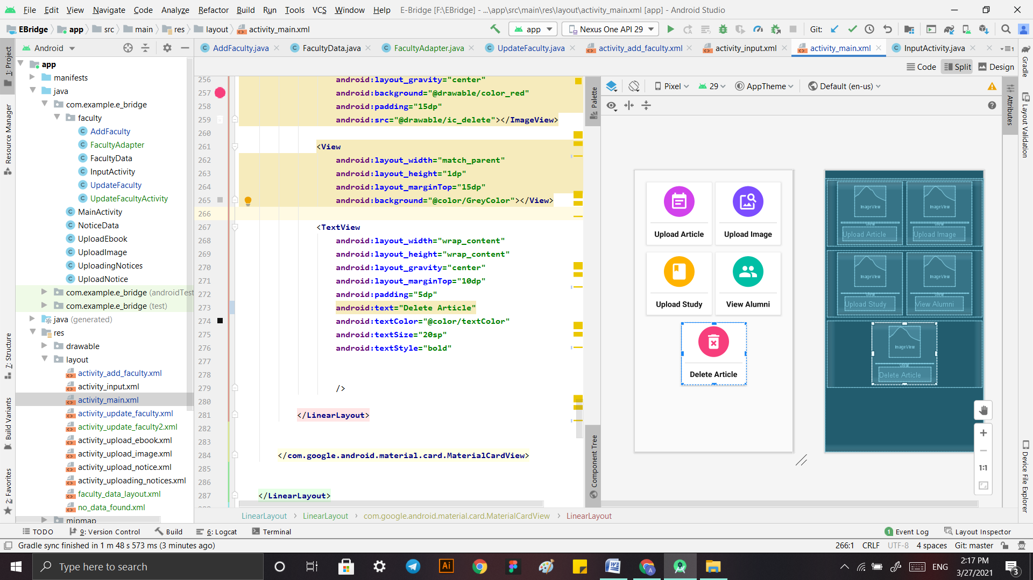

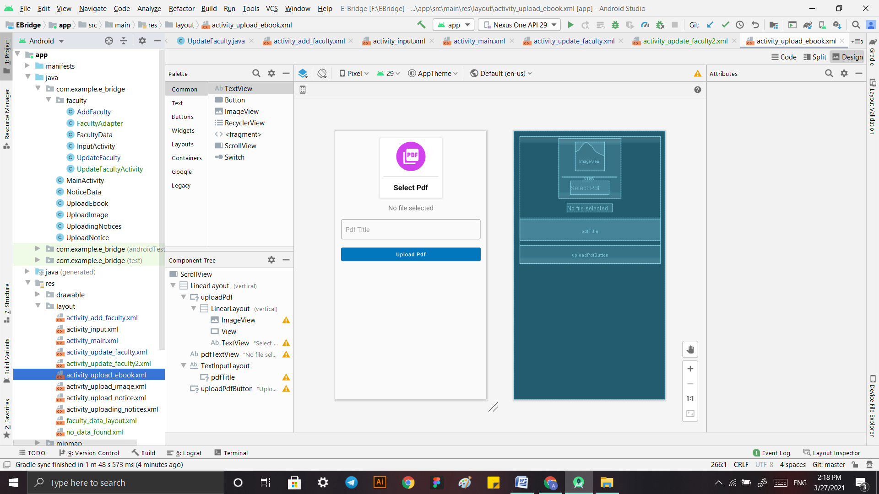

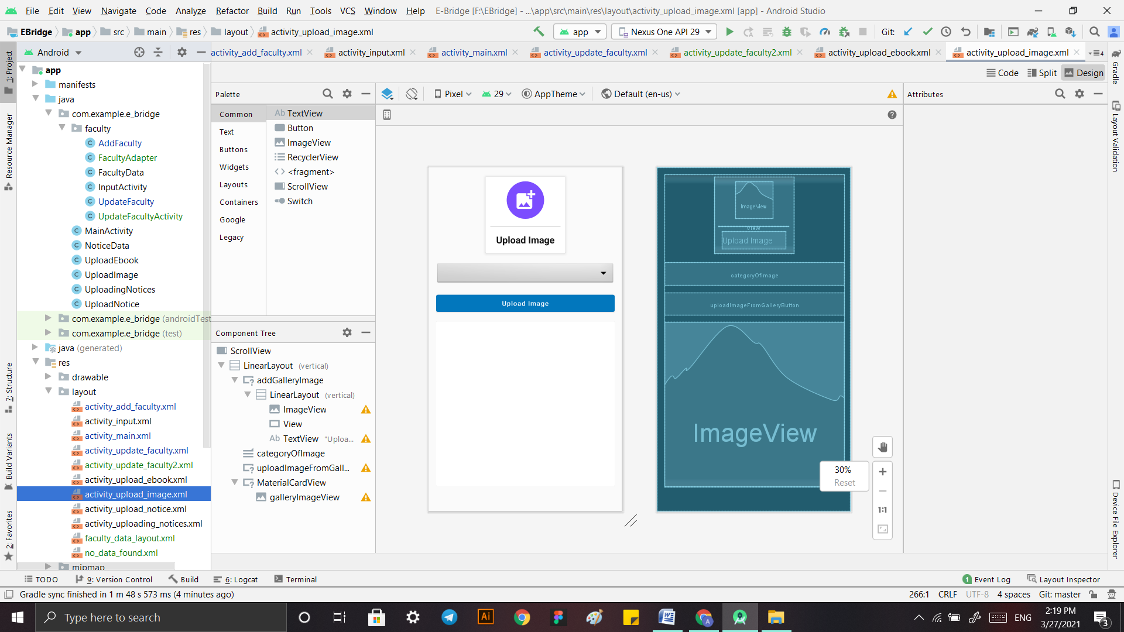

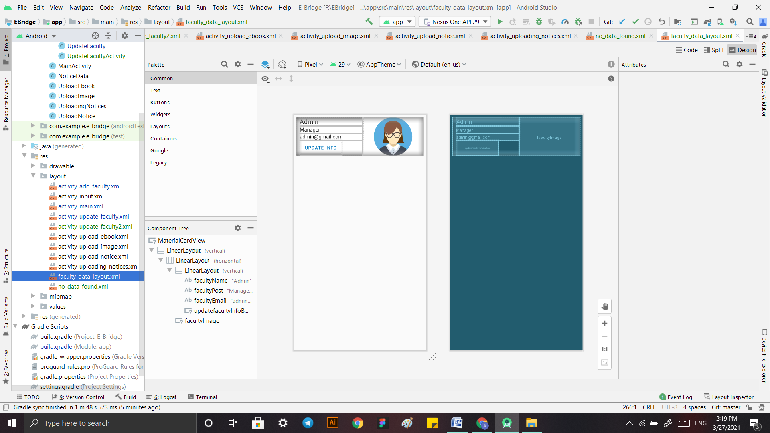

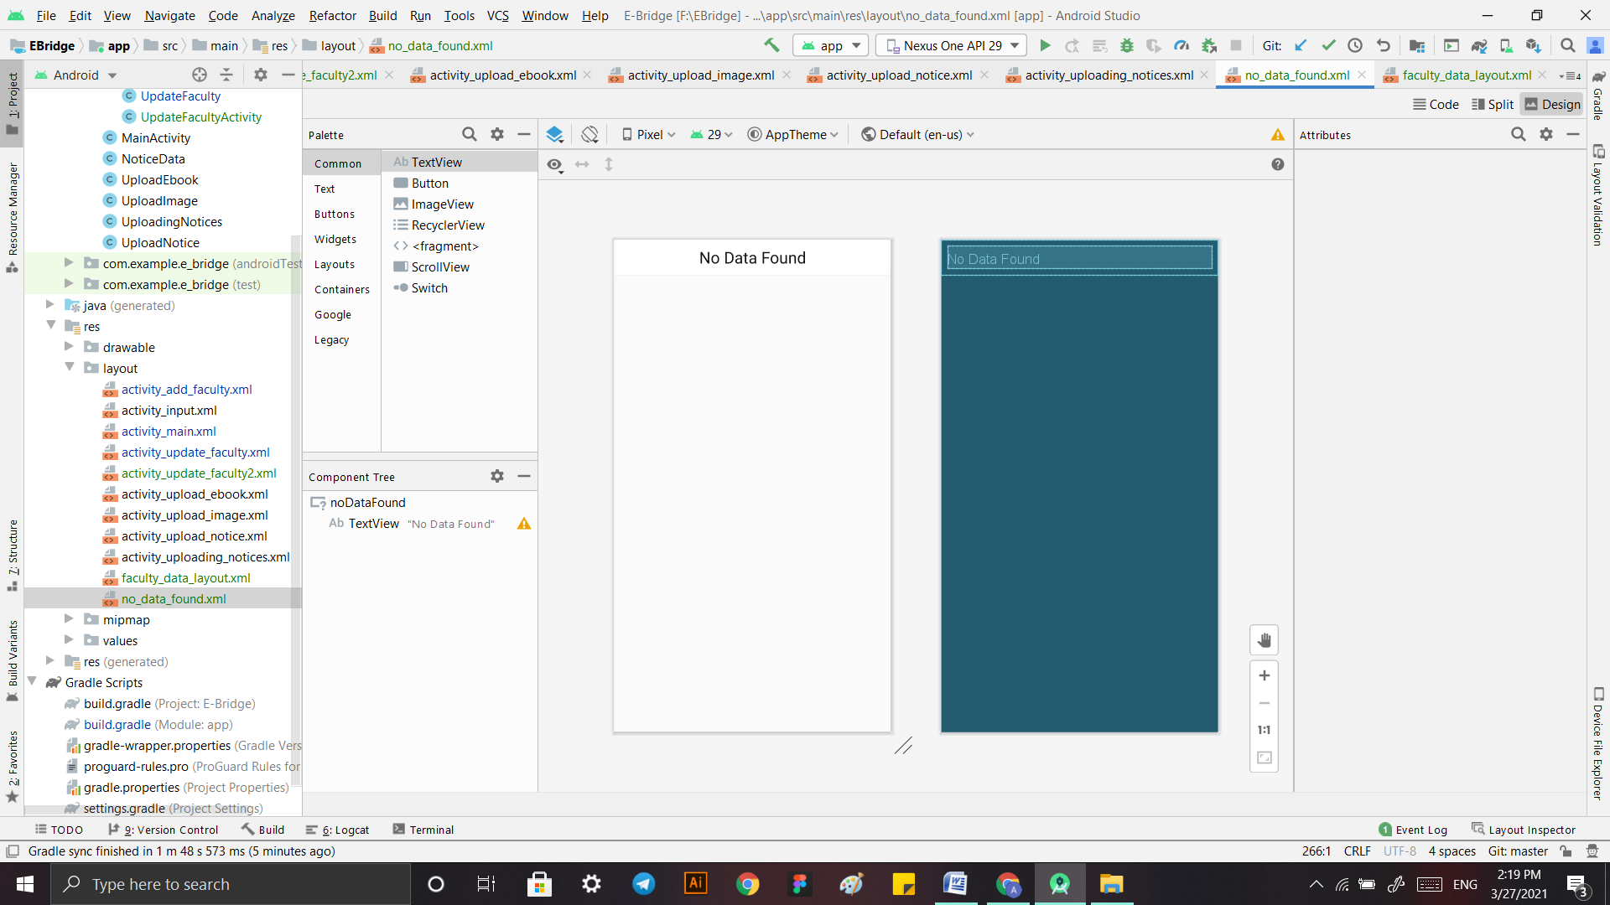

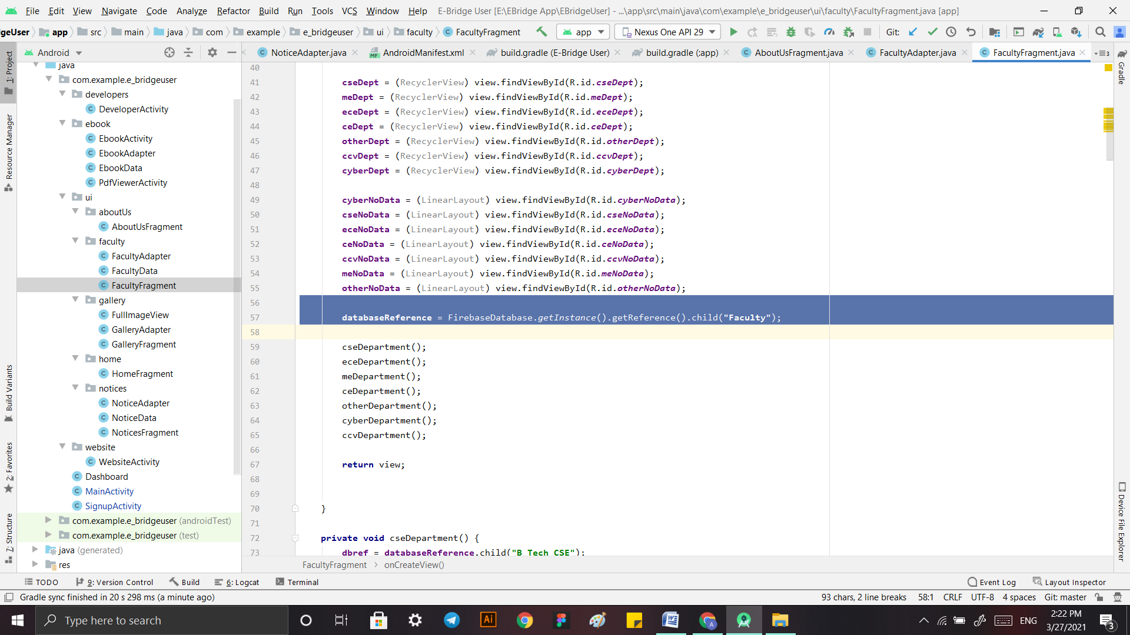

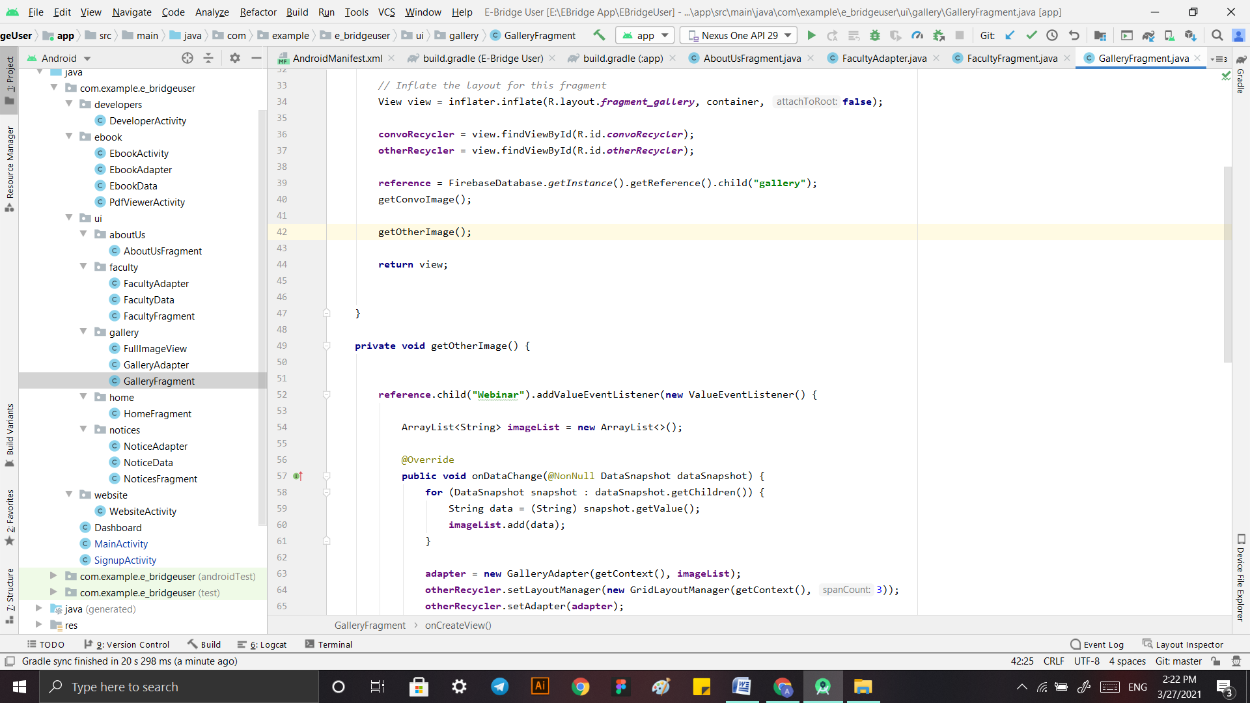

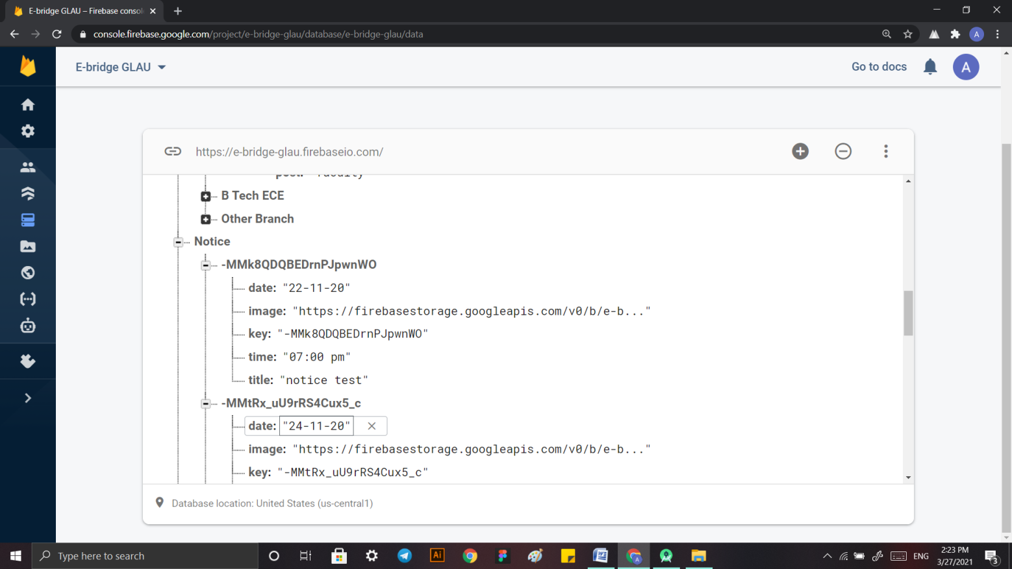

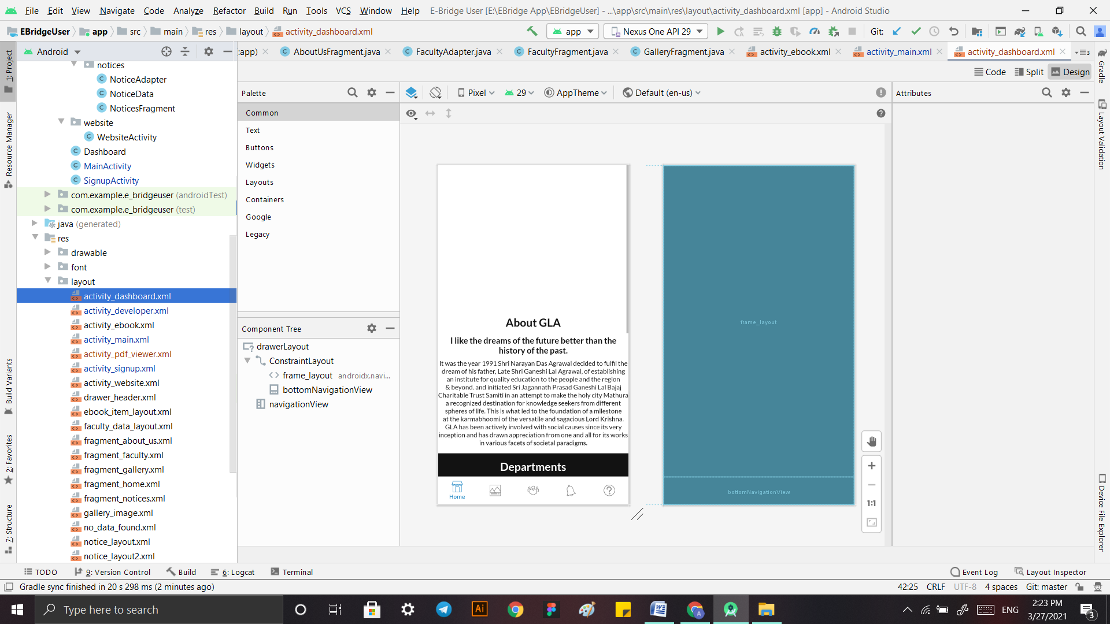

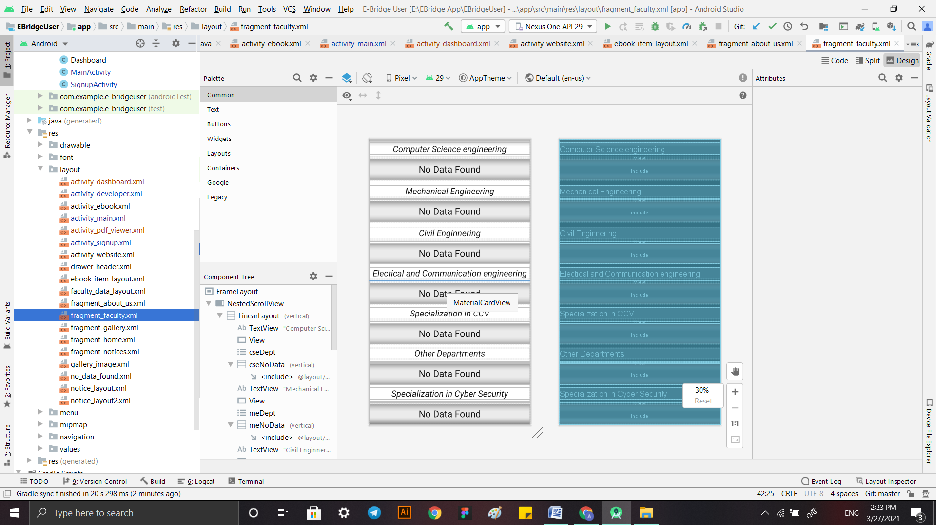

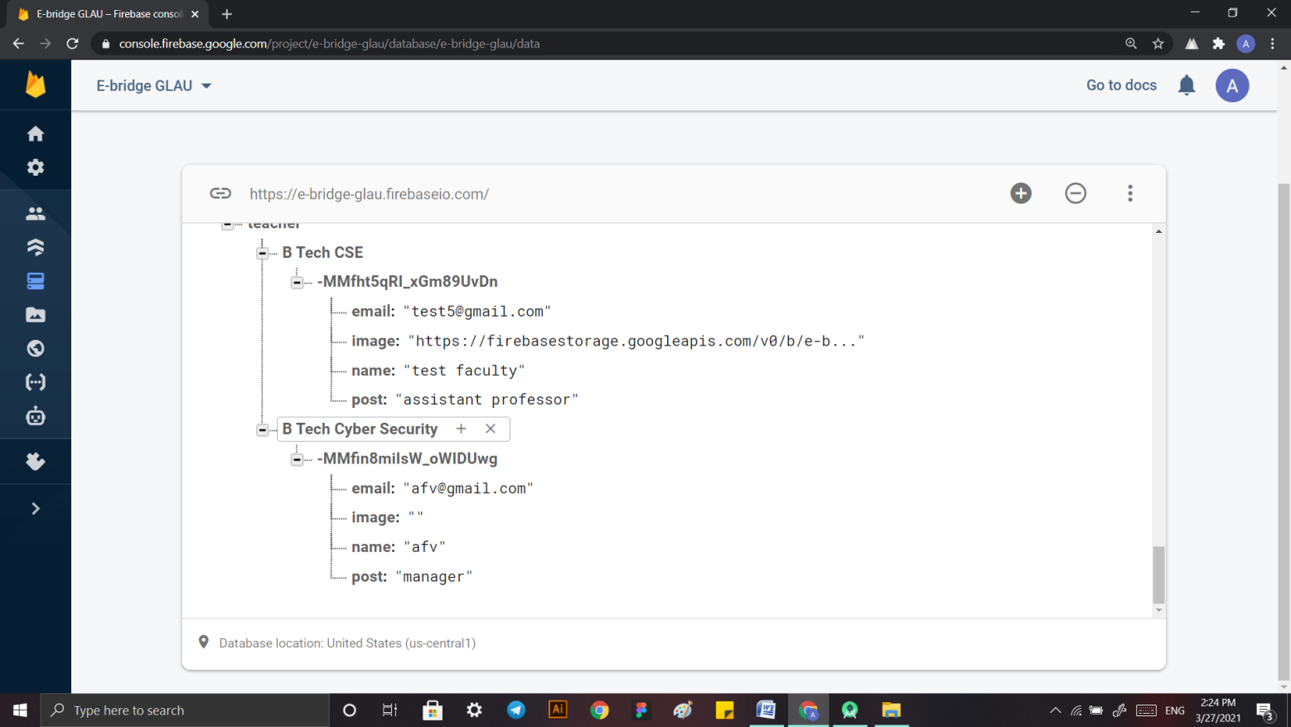

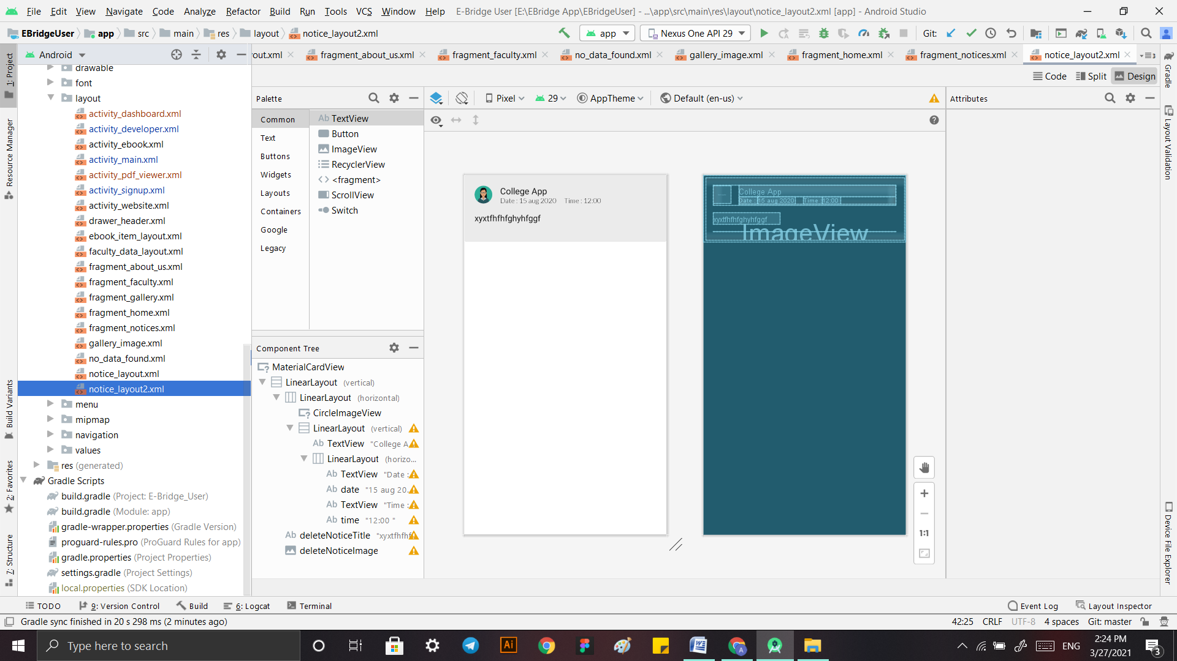

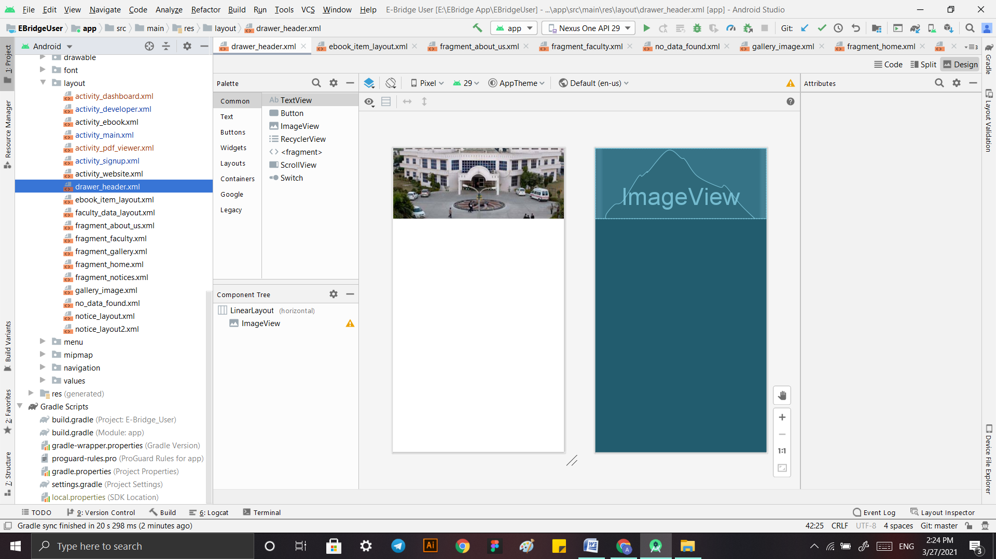

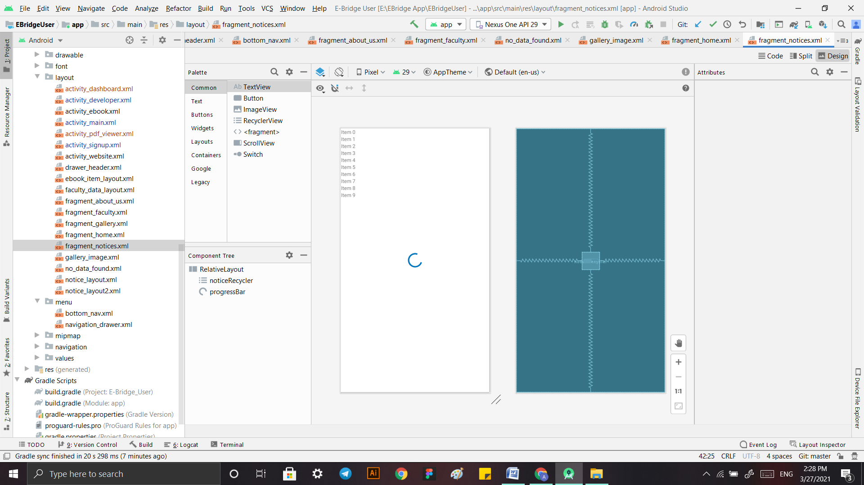

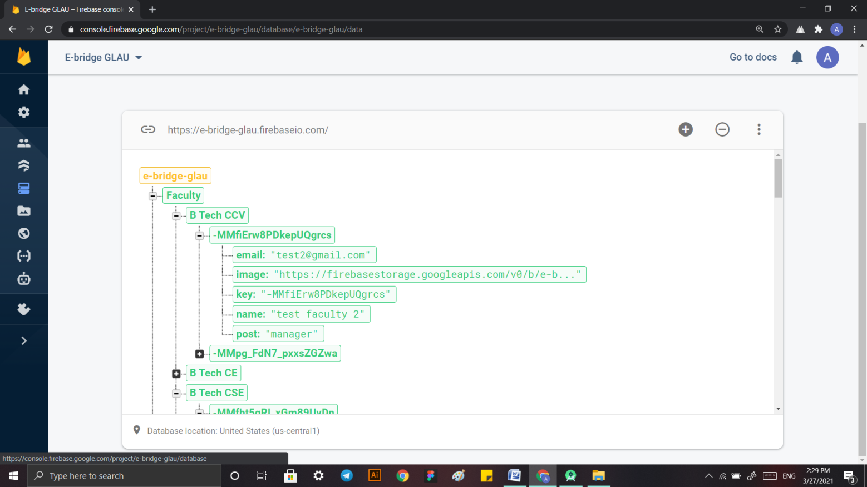

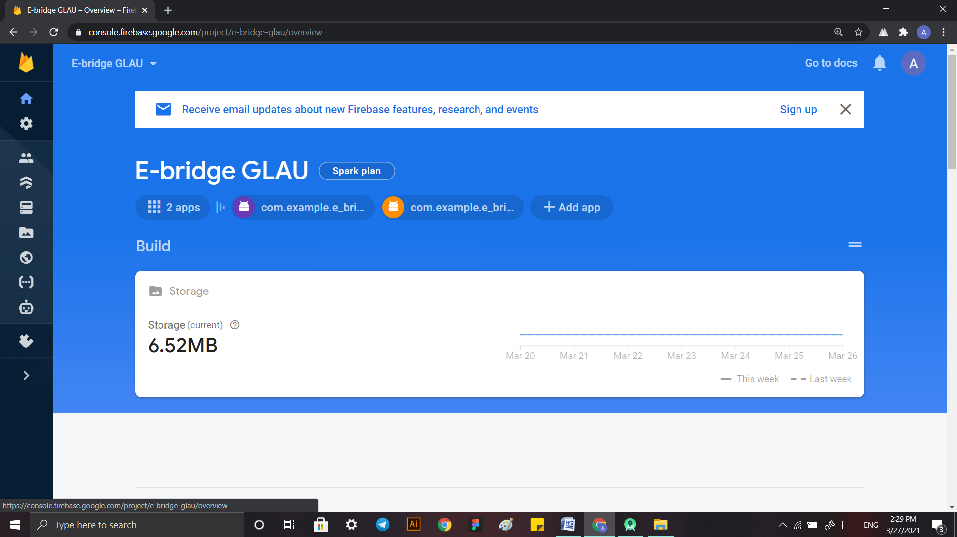

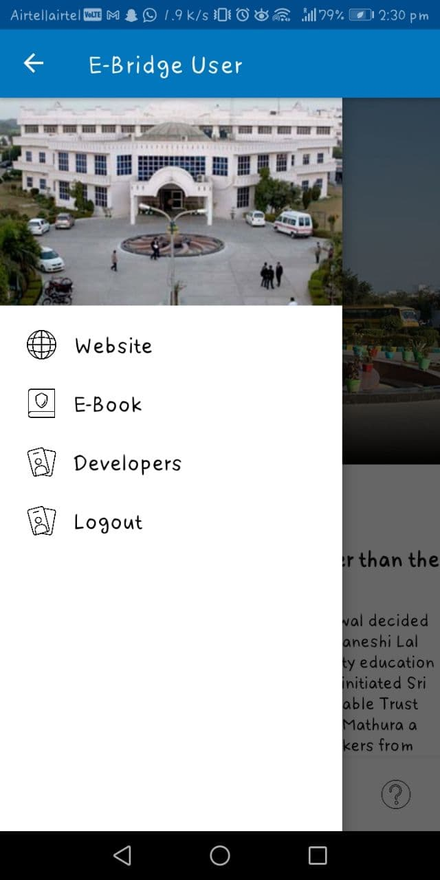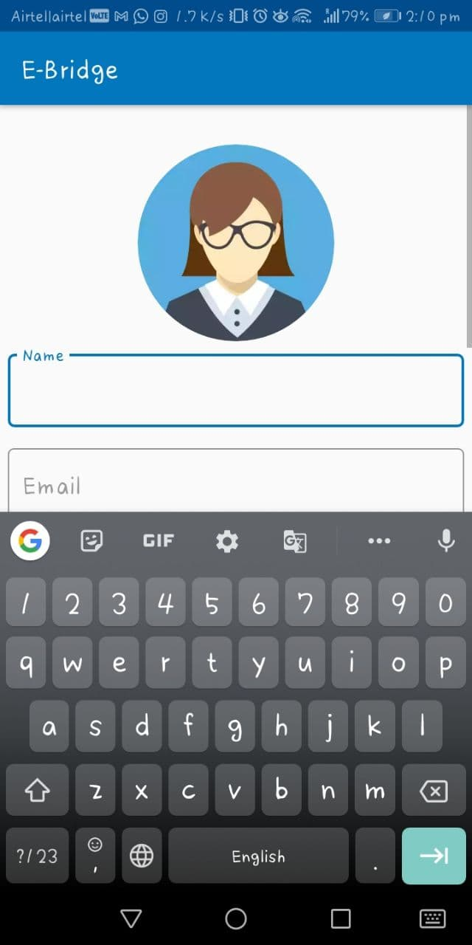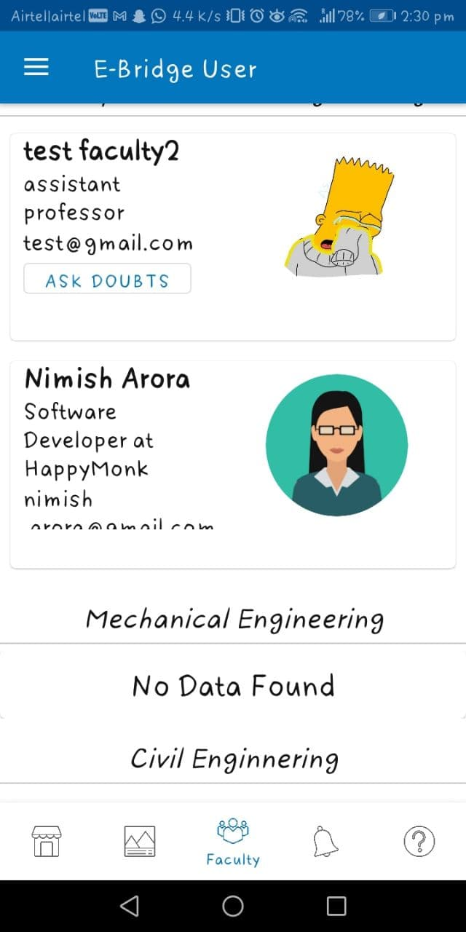

**References**

* <https://www.signalvine.com/alumni/why-alumni-are-important-for-higher-ed-institutions#:~:text=Alumni%20serve%20many%20valuable%20roles,and%20career%20opportunities%20to%20students>.
* <https://www.themuse.com/advice/7-alumni-benefits-you-should-be-taking-advantage-of>